**RMSE Analysis : 10 day vs 14 day**

**Overview :**

RMSE (Root Mean Square Error) was computed between Fourcastnet Model predictions and ERA5 reanalysis data.

The evaluation was done across 4 variables : Temperature, U Wind, V Wind, Mean Sea Level Pressure.

**10 day Forecast Observations :**

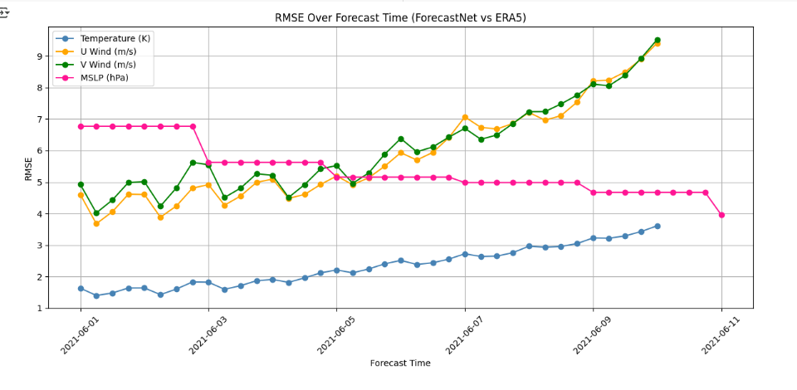

* MSLP shows consistently low and stable RMSE, indicating strong surface pressure predictions.
* Temperature and wind components exhibit gradual RMSE growth, showing stable performance up to 10 days.
* Overall, forecast skill remains reliable within this range.

**14 day Forecast Observations :**

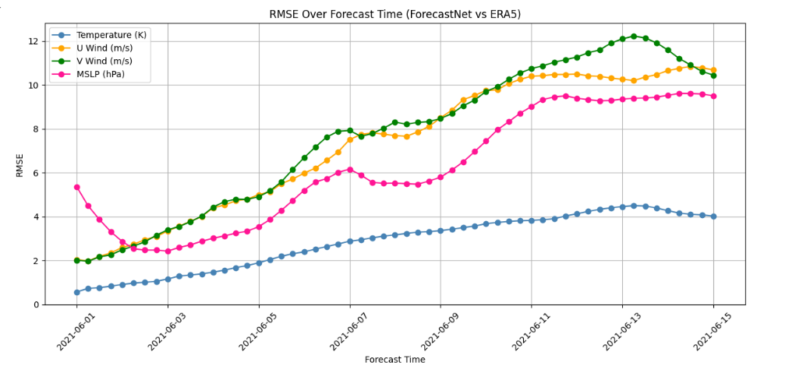

* A notable increase in RMSE is observed beyond day 10, especially for: u-wind, v-wind
* This suggests a drop in forecast accuracy at longer lead times for dynamic atmospheric variables.
* Temperature forecasts remain the most stable and accurate, even beyond day 10.
* MSLP error rises slightly, but less dramatically compared to wind.

**Conclusion :**

FourcastNet demonstrates reliable performance across all core atmospheric variables up to a 10-day forecast horizon. Beyond this range, the model's accuracy begins to decline noticeably, particularly for wind components such as U and V wind. This degradation is likely due to the increased influence of atmospheric chaos and limitations in the model’s long-range dynamics. In contrast, temperature forecasts remain relatively stable and less sensitive to extended lead times, highlighting their robustness. These findings offer useful insight into the operational forecasting limits of FourcastNet and point to the need for potential model refinement or ensemble approaches for improved performance beyond 10 days.